**Building Emergency Response Plan**

**BEATY BIODIVERSITY RESEARCH CENTRE AND MUSEUM**

**2212 MAIN MALL**

**Vancouver, BC**

To comply with the *Freedom of Information and Protection of Privacy Act* (FIPPA), the information within this document should only be retained as long as required, should only be used for the authorized purpose it was collected for, and access should be restricted to a needs only basis (i.e. only those staff and faculty of a particular building that the Building Emergency Response Plan was developed for should have access to it).

f

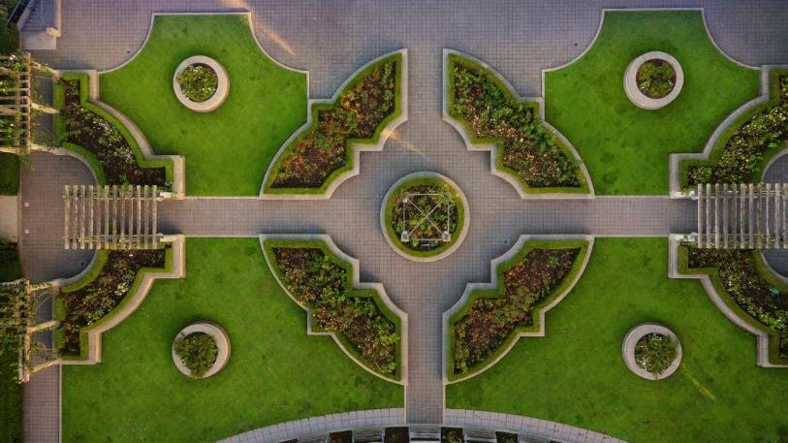

To be updated annually

Or as needed to include personnel

and/or facility changes



Risk Management Services

[www.rms.ubc.ca](http://www.rms.ubc.ca/)

To be reviewed annually

Or as needed to include personnel

And/or facility changes



# 

# Table of Contents

Table of Contents i

Emergency and Safety Contacts 1

Emergency Response Plan 2

Objectives 3

Life Safety Systems and Building Features 4

Life Safety Systems and Building Features 5

Life Safety Systems and Building Features 6

Contacts – Building Emergency Directors and Building Floor Wardens 7

Persons with Impairment 10

Occupational First Aid 11

Responsibilities 12

Responsibilities 13

In the case of a Building Fire 14

In the Case of a Building Fire 15

In the Case of a Building Fire 17

In the Event of a Power Outage 18

In the event of an Earthquake 19

In the event of an Earthquake 20

In the event of an Earthquake 21

In the event of an Earthquake 22

In the event of an Earthquake 23

In the event of an Earthquake 24

If you use a wheelchair 24

In the event of an explosion or fire due to Hazardous Materials 25

In the event of a Gas Leak 26

In the event of a Chemical, Biological or Radiation Spill 27

In the event of a Bomb Threat 28

In the event of receiving a suspicious package 29

In the event of an Active Shooter 30

Fire Evacuation Drills – Procedures and Records 31

Appendix 1: Automated Emergency Defibrillator Locations 32

Appendix 2: Emergency Response Key Plans 35

Appendix 3: Building Site Plan 41

Appendix 4: Persons Requiring Assistance 42

Appendix 5: Personal Evacuation Plan 47

Appendix 6: Elevator Upgrade Project 48

Appendix 7: Operating a Fire Extinguisher 49

Appendix 9: List of Contributors 54

# Emergency and Safety Contacts

**EMERGENCY:** 

**911**

**Police | Fire | Ambulance | Hazardous Spill**

|  |  |
| --- | --- |
| **NON-EMERGENCY** | |
| RCMP | 604 224 1322 |
| Vancouver Fire and Rescue | 604 665 6010 |
| BC Ambulance Service | 604 872 5151 |
| **SECURITY & PERSONAL SAFETY RESOURCES** | |
| Campus Security (Vancouver) | 604 822 2222 |
| AMS SafeWalk | 604 822 5355 |
| **FIRST AID RESOURCES** | |
| Closest Automated External Defibrillator | Main Building entrance |
| UBC Faculty, Staff, and Student Workers | 604 822 4444 |
| UBC Students | 911 or Student Health at UBC Hospital |
| Visitors | 911 or Urgent Care at UBC Hospital (604.822.7662) |
| **SAFETY RESOURCES & RISK MANAGEMENT SERVICES CONTACTS** | |
| AMS Sexual Assault Support Centre | 604 827 5180 |
| Asbestos Safety | 604 822 8772 |
| Biological and Radiation Safety | 604 822 4353 |
| Chemical Safety | 604 827 3409 |
| Emergency Management & Business Continuity | 604 822 1237 |
| Environmental Services | 604 822 9280 |
| Health and Safety- Faculty of Medicine | 604 827 1982 |
| Health and Safety- Student Housing and Hospitality Services | 604 827 2671 |
| Health and Safety- Building Operations | 604 822 1885 |
| Report an Accident or Incident | [www.cairs.ubc.ca](http://www.cairs.ubc.ca) |
| Risk Management Services | 604 822 2029 |
| Safety Programs | 604 822 6513 |
| Student Health | 604 822 7011 |
| Equity and Inclusion | 604 822 6353 |
| Counseling Services | 604 822 3811 |
| Ergonomics | 604 822 9040 |
| Occupational Hygiene | 604 822 6098 |

# Emergency Response Plan

The Emergency Response Plan (ERP) provides the University of British Columbia Vancouver (UBC-V) campus with a management framework to prepare, respond and recover from emergencies affecting the entire UBC-V community. The ERP incorporates as its foundation for response, the British Columbia Emergency Management System (BCEMS) as seen in Figure 1.

Figure 1: BC Emergency Management System Response Structure

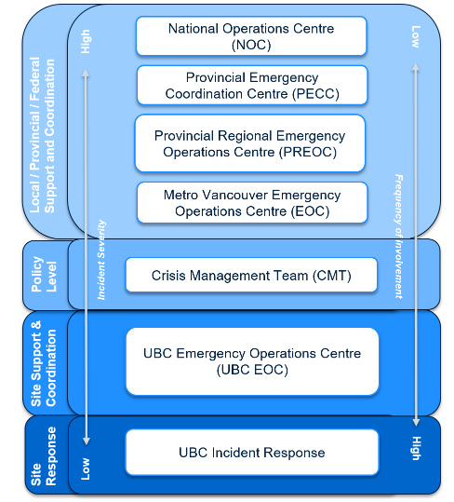

UBC Vancouver’s emergency response structure is divided into three levels—Site Response, and Site Support and Coordination, and Policy Level (governance and oversight). During any incident, communication flows both up and down the structure.

To respond to an emergency at the site level, Building Emergency Directors, Building Floor Wardens, Risk Management Services, First Responders and other resources work together. The Building Emergency Response Plan (BERP) details site response procedures for various emergencies.

# Objectives

The objectives of the Building Emergency Response Plan (BERP) are:

1. **To ensure the safety of the building occupants through:**

**Fire Prevention**

To reduce and prevent the incidence of fire by controlling fire hazards in the building and by maintaining the building facilities (see pages 10-11 “Responsibilities” for both the Building Emergency Director and the Building Floor Warden responsibilities);

And,

**Emergency Evacuation**

To establish a systematic method of safe and orderly evacuation of an area or building, in case of fire, bomb threat, earthquake, explosions, fires, gas leaks, or release of hazardous materials

1. **To provide procedures for responding to and reporting an emergency.**
2. **To assist with recruiting and training of Building Emergency Directors and Building Floor Wardens.**

The Building Emergency Response Plan has been designed and produced for distribution to all building occupants.

A priority in any emergency situation is to:

1. **Save lives**
2. **Minimize injuries**
3. **Reduce Damage to Property**

# Life Safety Systems and Building Features

Building Name: Beaty Biodiversity Centre

Building Address: 2212 Main Mall

Life Safety Systems in the building consist of the following:

**Click on check box to indicate that the Life Safety System is present in the building**

Automated External Defibrillators (AEDs)

Emergency exits

Emergency lighting

Emergency power

Fire alarm pull station

Fire extinguisher(s)

Fire hose cabinets

Standpipes

Fire hydrant(s)(outside building)

Fire pump

Sprinkler system

Area(s) of Refuge

***(Modify or remove the following information as necessary to correctly reflect the status of your building. If necessary, add additional information.):***

**Automated External Defibrillators (if applicable)**

Automated External Defibrillators (AEDs) provide quick response in the event of a cardiac arrest and can increase the chance of saving someone’s life.

An AED is a portable unit that provides a life-saving shock to a person in sudden cardiac arrest. Sudden cardiac arrest is when the heart unexpectedly and abruptly stops beating. This is usually caused by an abnormal heart rhythm called ventricular fibrillation.

Once applied, the AED analyzes a patient’s heart activity and determines if a life-saving shock is required. The AED cannot deliver a shock unless the person is in cardiac arrest.

AEDs are now available at a number of publicly accessible buildings across UBC’s Vancouver campus (if there is no AED in you building, see **Appendix 1: Automated External Defibrillator Locations** to find the nearest AED to you). If the location of the AED is not indicated on your Building’s Emergency Key Plans, use the contact information provided in **Appendix 2: Emergency Response Key Plans** to obtain an updated EKP that lists this information.

The portable AED devices are located in a white cabinet and have an AED sign above the unit. In the event of an emergency, when a defibrillator is required, 9-1-1 dispatchers can also provide direction to the nearest AED.

# Life Safety Systems and Building Features

**Emergency Exits**

Emergency exits are located throughout the building and marked by lighted signs and placards. Maintenance of lighted emergency exit signs is handled by UBC Building Operations. Refer to APPENDIX 2: Emergency Response Key Plans to find out how to obtain EKP for your building.

**Emergency Lighting (if applicable)**

In the event of a power failure, emergency lighting may be available to cover all common corridors, stairwells and exit signage. Maintenance of emergency lights is handled by UBC Building Operations.

**Emergency Power (if applicable)**

A power generator may be available for your building and is located at Room 082 in the basement. In the event of a power failure, this unit provides power to emergency lighting, exit signage, elevators and all related emergency equipment. See page 15 for “In the case of a Power Outage” procedure.

**Fire Alarm System**

Fire alarm pull stations and smoke detectors are located throughout the building. Fire alarm system is monitored by Vancouver Fire & Rescue Services through the 911 dispatch Centre (E-Comm). Fire alarm system maintenance is handled by UBC Building Operations. The locations of fire alarm pull stations are indicated on **Appendix 2: Emergency Response Key Plans.**

**Fire Extinguisher(s)**

Portable fire extinguishers placed strategically (i.e. visible and accessible) throughout the building. Refer to **Appendix 2: Emergency Response Key Plans** for locations of portable fire extinguishers.

**Fire Hydrant(s)**

Refer to **Appendix 3: Building Site Plan** for locations of fire hydrants located near the building.

**Fire Pump (if applicable)**

A fire pump may be installed in this building and is designed to increase and maintain water pressure in the standpipe during fire-fighting operations. It is in the sprinkler room or other location. The location of the fire pump is: N/A

**Sprinkler System (if applicable)**

A sprinkler system may be installed in this building. The main control valves are in the sprinkler room at: 080 in the basement.

# 

# Life Safety Systems and Building Features

**Area of Refuge**

Area(s) of Refuge are predesignated locations in a building to hold occupants during a fire and/or other emergency or when evacuation may not be safe or possible. Area(s) of Refuge must: not be moved, remain in place, and never block any Means of Egress.

It is not standard for new buildings to have Area(s) of Refuge. In these buildings, occupants who require assistance must be placed in a safe location that is away from the hazard. The location of these occupants must be reported to the Emergency Responders (Fire Department) through the Building Emergency Directory and/or Building Floor Wardens *immediately*.

Ramp if safe – lobby near elevator 1 (114 area on map)

# Contacts – Building Emergency Directors and Building Floor Wardens

The pre-determined meeting location for Building Emergency Directors and Building Floor Wardens is: . On Main Mall, west of the whale on the grass.

The Predesignated Meeting Area for Building Occupants is: On Main Mall, west of the Whale on the grass.

|  |  |  |
| --- | --- | --- |
| **POSITION** | **PHONE NUMBER** | |
| **WORK** | **OTHER (e.g. work mobile)** |
| Building Emergency Director  **Name: Katie Beall**  brcadmin@biodiversity.ubc.ca | 604-822-0862 |  |
| Deputy Building Emergency Director  **Name: Catherine Ouellet- Martin**  catherine.ouellet-martin@ubc.ca | 604-827-4807 |  |
| Building Floor Warden – Basement (Lower Floor) Lab wing  **Name: Christopher Stinson**  [cstinson@zoology.ubc.c](mailto:cstinson@zoology.ubc.c)a | 604-822-4665  605-822-5491 | 604-221-2622 |
| Building Floor Warden - Basement(Lower Floor)Office Wing  **Name: Karen Needham**  [needham@zoology.ubc.ca](mailto:needham@zoology.ubc.ca) | 604-822-3379 |  |
| Alternate Building Floor Warden – Basement (Lower Floor)  **Name: Olivia Lee**  [**olivia@mail.ubc.ca**](mailto:olivia@mail.ubc.ca) | 604-822-3344 |  |
| Building Floor Warden – Public Museum  **Name: Any Interpreters on Duty**  **Main Contacts:**  **Nancy Lee [Nancy.Lee@beatmuseum.ubc.ca](mailto:Nancy.Lee@beatmuseum.ubc.ca)**  **Nicole Balsdon**  [**Nicole.balsdon@ubc.ca**](mailto:Nicole.balsdon@ubc.ca) | 604-822-3320 |  |
| Building Floor Warden – Level 1 (Main Floor) Office Wing  **Name: Katie Beall**  [brcadmin@biodiversity.ubc.ca](mailto:brcadmin@biodiversity.ubc.ca) | 604-822-0862 |  |
| Alternate Building Floor Warden - Level 1(Main Floor) Office Wing  **Name: Alistair Blachford**  **alistair@zoolgy.ubc.ca** | 604-822-2645 |  |
| Building Floor Warden - Level 1 (Main Floor) Lab Wing  **Name: Evan Morien**  **morien@zoology.ubc.ca** |  |  |
| Building Floor Warden - Level 1 (Main Floor) Lab Wing  **Name: Colin MacLeod**  [cmacleod@zoology.ubc.ca](mailto:cmacleod@zoology.ubc.ca) |  |  |
| Building Floor Warden - Level 1 (Museum Floor)  **Name: Admissions staff on duty**  [ubcbmus-g-Admissions@mail.ubc.ca](mailto:ubcbmus-g-Admissions@mail.ubc.ca) | 604-827-4955 |  |
| Building Floor Warden - Level 2 (Second Floor)Office Wing  **Name: Dolph Schluter**  [**schluter@zoology.ubc.ca**](mailto:schluter@zoology.ubc.ca) | 604-822-2387 |  |
| Alternate Building Floor Warden - Level 2 (Second Floor) Office Wing  **Name: Jeannette Whitton**  [jeannette.whitton@botany.ubc.ca](mailto:jeannette.whitton@botany.ubc.ca) | 604-822-8863 | 604-822-8864 |
| Building Floor Warden - Level 2 (Second Floor) Lab Wing  **Name: Ben Freeman**  [freeman@zoology.ubc.ca](mailto:freeman@zoology.ubc.ca) |  |  |
| Alternate Building Floor Warden - Level 2 (Second Floor) Lab Wing  **Name: Wayne Maddison**  [wayne.maddison@ubc.ca](mailto:wayne.maddison@ubc.ca) |  |  |
| Building Floor Warden - Level 3 (Third Floor) Lab Wing  **Name: Winnie Cheung**  winniecw228@gmail.com |  |  |
| Building Floor Warden - Level 3 (Second Floor) Lab Wing  **Name: Racquel Singh**  racquelsingh21@yahoo.com |  |  |

**NOTE**: Do not include personal home phone numbers on this list. This document is a workplace document and it is meant for UBC faculty and staff, so it must not include any external personal contact information.

# Persons with Impairment

# 

**Locations/ Plans**

If persons requiring assistance are in your workplace, please refer to **Appendix 4: Persons Requiring Assistance** and **Appendix 5: Personal Evacuation Plan**. Summarize on the table below, Building Occupants in your area that require assistance during an emergency evacuation but ensure a Personal Evacuation Plan is developed.

|  |  |  |  |
| --- | --- | --- | --- |
| **NAME** | **AREA** | **WORK PHONE NUMBER** | **PROVIDE SUMMARY OF PERSONAL EVACUATION PLAN**  **(See Appendix 5 For Full Plan)** |
| *John Smith* | *2nd Floor, Room 200* | *604-xxx-xxxx* | *Matt Smith will meet John Smith at John’s desk. Matt will assist John evacuate the building.* |
| **Name:** |  |  |  |
| **Name:** |  |  |  |
| **Name:** |  |  |  |
| **Name:** |  |  |  |

Person in these rooms need assistance – not in public version with names

# Occupational First Aid

First Aid at UBC is a free service available 24 hours a day for all UBC employees. The mobile first aid service is available by calling **604 822 4444** (or 2 4444 from a University telephone). Injured visitors or unpaid students can call **911**. Students can also attend Student Health Services in the UBC Hospital.

**In the event of a medical emergency all faculty and staff should call 911 and then first aid at**

**604 822 4444.**

This will ensure the quickest response for assistance.

# Responsibilities

**Building Emergency Director**

The Building Emergency Director supervises and maintains the BERP.

The Building Emergency Director ensures each floor has enough floor wardens to properly evacuate the building. Having one (1) alternate for each position (Building Emergency Director and Building Floor Wardens) is required; however, having two (2) alternate is recommended. In addition, the Building Emergency Director is responsible for ensuring the Building Floor Wardens are trained to perform their duties in fire prevention and emergency evacuation of the building. All Building Emergency Directors and Building Floor Wardens should take the Floor Warden Training course available through Risk Management Services via [www.rms.ubc.ca](http://www.rms.ubc.ca/) or request a building specific in person floor warden training from RMS (604 822 6513).

The Building Emergency Director maintains proper records of current Building Floor Wardens, evacuation times of fire drills, fire and emergency incidents in the building, fire prevention activities, and a list of regular building occupants with disabilities. Full inspection and maintenance of the fire safety equipment is the responsibility of UBC Building Operations. However, if any occupant or Building Floor Warden notices fire safety equipment in need of repair, they must notify the Building Emergency Director, who will contact Building Operations Service Centre at 604 822 2173.

# Responsibilities

**Building Floor Wardens**

The Building Floor Wardens MUST be familiar with their assigned areas to ensure a safe and orderly evacuation. The role of a Building Floor Warden is to lead the evacuation of building occupants within their designated area. They are responsible for recording the names and locations of areas of concern (e.g. locked doors, missed areas, people who are unable or refuse to evacuate). These concerns must be reported directly to the Building Emergency Director. The Building Emergency director reports all information to the Fire Chief. If the Building Emergency Director is unavailable, the Building Floor Wardens shall their report to the Fire Chief or any member of the Fire Department.

Building Floor Wardens should check their floor or area regularly for:

* Accumulation of combustible material, rubbish, or flammable liquids in excess of quantities allowed by permit.
* Dangerous ignition sources (e.g. worn extension cords, oily rags, overheating equipment).
* Hazardous equipment such as portable heaters must never be left unattended. One must ensure heat emitting equipment is not next to cardboard boxes, paper, or any combustible materials.
* Exit signs in good order and adequate lighting in public corridors and stairwells.
* Fire and exit doors and their self-closing hardware in good operating condition (Doors should not be wedged open under any conditions).
* Exit routes (means of egress) are unobstructed.
* Fire hose and portable fire extinguishers are not obstructed, in good order and ready to use.
* Emergency Response Key Plans are correct.

All fire hazards that are discovered must be reported to the Building Emergency Director immediately for corrective action.

**Building Occupants**

Building Occupants **MUST be familiar with this plan** and know all the locations of the building evacuation route(s) and exit(s). During an evacuation, Building Occupants MUST follow instructions of Building Floor Wardens and/ or the Building Emergency Director.

**If you require assistance during an evacuation, please notify Building Emergency Director and Building Floor Wardens right away to facilitate a Personal Evacuation Plan (See Appendix 5: Personal Evacuation Plan)**

# In the case of a Building Fire

**Building Emergency Directors - Instructions**

1. Ensure pull alarm has been activated.

**Note 1: Appendix 6:** **Elevator Upgrade Project**, provides information on the elevator upgrades occurring across campus in efforts to meet the requirements of the Safety Code for Elevators and Escalators. In an emergency, elevators are not to be considered the primary mechanism for egress.

1. If immediately accessible, put on your safety vest.
2. Ensure nearby floor wardens proceed through their areas advising occupants to evacuate the building.
3. Urge people to stay calm and evacuate in a quick and orderly manner. WALK, DO NOT RUN.
4. If it is safe to do so, close (do not lock) doors and windows on your way out. This will help to prevent oxygen from feeding the fire, provide containment, and slow the advancement of the fire.
5. Use the stairway to evacuate; DO NOT use the elevator(s). See Note 1.
6. If possible, assist occupants that are unable to evacuate using the stairs by moving individuals to an area of refuge or a safe location. Individuals requiring assistance are required to have a personal evacuation plan. Refer to **Appendix 4: Persons Requiring Assistance** and **Appendix 5: Personal Evacuation Plan.** Alternatively, individuals having difficulty can be directed to an area of refuge or a safe location inside the building, Lobby areas on each floor next to elevator 2(areas 010, 114, 214, & 314 on plans in Appendix 2). Within Museum the safe location will be the base of the ramp. Building Floor Wardens and Building Emergency Directors must relay the location of these occupants to the Fire Department.
7. Upon exiting the building, direct evacuated occupants to proceed to the Predesignated Meeting Area. The building’s Predesignated Meeting Area is: on Main Mall directly west of the Whale on the grassy area.
8. Ensure 911 is called:
9. State your name
10. Provide the address and the nearest intersection. The address of your building is: 2212 Main Mall nearest to University Boulevard and Main Mall
11. Provide the following information about the fire:
    * **WHERE:** Floor number, room number
    * **WHEN:** Approximate time fire started
    * **WHAT:** What caused the fire, is it spreading, are people injured or requiring urgent assistance
    * **OTHER INFORMATION:** Hazardous materials, potential access issues etc.
12. Proceed to pre-determined meeting location for Building Emergency Directors and Building Floor Wardens (e.g. at an open area that is a safe distance away from the building). The pre-determined meeting location for Building Emergency Directors and Building Floor Wardens is: on Main Mall directly to the west of the whale on the grassy area.
13. Ensure pertinent information reported from the Building Floor Wardens is relayed to the Fire Department.
14. Stay on scene until the Fire Department arrives. Once evacuated, DO NOT ALLOW ANYONE TO RE-ENTER THE BUILDING until the Fire Department gives permission to do so.

# In the Case of a Building Fire

**Building Floor Wardens – Instructions**

**Note 1: Appendix 6:** **Elevator Upgrade Project**, provides information on the elevator upgrades occurring across campus in efforts to meet the requirements of the Safety Code for Elevators and Escalators. In an emergency, elevators are not to be considered the primary mechanism for egress.

1. If not activated, activate the closest fire pull alarm immediately.
2. If immediately accessible, put on your safety vest.
3. Direct all personnel within your area to the nearest safe exit.
4. Urge people to stay calm and evacuate in a quick and orderly manner. WALK, DO NOT RUN
5. Knock on closed and/or locked doors, state the nature of the emergency and proceed without delay to sweep through area. Ensure you evacuate with your assigned personnel and report any rooms/areas that were locked or inaccessible.
6. If it is safe to do so, close (do not lock) windows and doors on your way out. This will help to prevent oxygen from feeding the fire, provide containment, and slow the advancement of the fire.
7. Use the stairway to evacuate; DO NOT use the elevator(s). See Note 1.
8. If possible, assist occupants that are unable to evacuate using the stairs. Individuals requiring assistance are required to have a personal evacuation plan. Refer to **Appendix 4: Persons Requiring Assistance** and **Appendix 5: Personal Evacuation Plan**. Alternatively, individuals having difficulty can be directed to an area of refuge or a safe location inside the building, Lobby areas on each floor next to elevator 2(areas 010, 114, 214, & 314 on plans in Appendix 2). Within Museum the safe location will be the base of the ramp. Building Floor Wardens and Building Emergency Directors must relay the location of these occupants to the Fire Department.
9. Direct evacuated occupants to the Predesignated Meeting Area upon exiting the building. The building Predesignated Meeting Area is: on Main Mall directly west of the whale on the grassy area.

**Note 2:** All Building Floor Wardens report information to Building Emergency Director and the Building Emergency Director reports all information to the Fire Department. If Building Emergency Director is unavailable, the Building Fire Wardens can report directly to the Fire Department.

1. Call 911:
2. State your name.
3. Provide the address and the nearest intersection. The address of your building is: 2212 Main Mall nearest intersection of Main Mall and University Boulevard.
4. Provide the following information about the fire:

* **WHERE:** Floor number, room number
* **WHEN:** Approximate time fire started
* **WHAT:** What caused the fire, is it spreading, are people injured or requiring urgent assistance
* **OTHER INFORMATION:** Hazardous materials, potential access issues etc.

1. Proceed to pre-determined meeting location for Building Emergency Directors and Building Floor Wardens

(e.g. at an open area that is a safe distance away from the building). The pre-determined meeting location for Building Emergency Directors and Building Floor Wardens is: Main Mall directly west of the whale on the grassy area.

1. Relay pertinent information (e.g. occupants who were unwilling or unable to evacuate the building) to the Building Emergency Director or Fire Department at an open area that is a safe distance away from the building. See Note 2
2. Stay on the scene until the Fire Department arrives. Once evacuated, DO NOT ALLOW ANYONE TO RE-ENTER THE BUILDING until the Fire Department gives permission to do so.

# In the Case of a Building Fire

# 

**Building Occupants – Instructions**

**Note 1: Appendix 6:** **Elevator Upgrade Project**, provides information on the elevator upgrades occurring across campus in efforts to meet the requirements of the Safety Code for Elevators and Escalators. In an emergency, elevators are not to be considered the primary mechanism for egress.

1. If it is not already activated, activate the closest fire pull alarm immediately.
2. Follow instructions of Building Floor Wardens during evacuation.
3. Leave the immediate area, alert others, and move everyone away from the area of the fire.
4. If it is safe to do so, close (do not lock) windows and doors on your way out. This will help to prevent oxygen from feeding the fire, provide containment, and slow the advancement of the fire.
5. Urge people to stay calm and evacuate in a quick and orderly manner;

however, ensure everyone is WALKING and NOT RUNNING.

1. Use the stairway to evacuate; DO NOT use the elevator(s). See Note 1.
2. If possible, assist occupants that are unable to evacuate using the stairs. Refer to **Appendix 4: Persons Requiring Assistance** and **Appendix 5: Personal Evacuation Plan**. Alternatively, individuals having difficulty can be directed to an area of refuge or a safe location inside the building, Lobby areas on each floor next to elevator 2(areas 010, 114, 214, & 314 on plans in Appendix 2). Within Museum the safe location will be the base of the ramp. Building Floor Wardens and Building Emergency Directors must relay the location of these occupants to the Fire Department.
3. Proceed directly to the Predesignated Meeting Area upon exiting the building, and wait for further instructions from the Building Emergency Director. The Predesignated Meeting Area is: on Main Mall directly west of the whale on the grassy area.
4. Call 911:
5. State your name
6. Provide the address and the nearest intersection. The address of your building is: 2212 Main Mall nearest intersection of Main Mall and University Boulevard
7. Provide the following information about the fire:
   * **WHERE:** Floor number, room number
   * **WHEN:** Approximate time fire started
   * **WHAT:** What caused the fire, is it spreading, are people injured or requiring urgent assistance
   * **OTHER INFORMATION:** Hazardous materials, potential access issues etc.
8. Once evacuated, DO NOT RE-ENTER THE BUILDING until the Fire Department gives permission to do so.

# In the Event of a Power Outage

**Building Emergency Directors, Floor Wardens and Building Occupants - Instructions**

1. If a power outage has occurred, consider exiting the building. Note: Emergency lighting may be battery powered and will only last 30 minutes. (There is a backup generator for the BBC so this should not be an issue). Lights may slowly dim and turn off making egress difficult. Consider other items like time of day and year.
2. If evacuation is determined necessary, due to a fire alarm or other emergency, urge people to remain calm and evacuate in a quick and orderly manner. Follow your Building Emergency Response procedures.

**Note 1: Appendix 6:** **Elevator Upgrade Project**, provides information on the elevator upgrades occurring across campus in efforts to meet the requirements of the Safety Code for Elevators and Escalators. In an emergency, elevators are not to be considered the primary mechanism for egress.

1. Use the stairway to evacuate; DO NOT use the elevator(s). WALK, DO NOT RUN. See Note 1.
2. Call Building Operations Service Centre: 604 822 2173.
3. State your name
4. Provide the building name of where the power outage is located and the nearest intersection.
5. Provide information about the power outage:

* **WHERE:** floor number, room number
* **WHEN:** When the power was lost, how long has emergency lighting been activated?
* **OTHER INFORMATION:** Are there any dangers associated with the loss of power?

1. Building Operations Service Centre will dispatch appropriate staff weekdays from 7:30am – 4:30pm. Before or after these times, crews may need to be called in which will add to delays of power restoral.
2. For large scale outages (affecting multiple buildings) Energy & Water Services staff will be automatically notified through computer generated messaging and will respond immediately.
3. For any total building outage, all admin staff will be updated at regular intervals, via email and SMS texts, as to the expected restoration times. Restoration times can vary up to two hours.
4. For outages affecting small areas or portions within a single building, local admin will be updated through the Facility Manager.
5. Researchers that have -80 degree freezers should not open any freezers and plan to obtain dry ice in case of outages that could last greater than 4 hours.
6. Once power has been restored to your facility, wait at least 5 minutes before entering the building to confirm power stability.
7. Once power has been restored, all admin staff will receive confirmation via email and SMS texts or through their Facility Manager.

NOTE: Please see Beaty Biodiversity Manual for more detailed information on the public museum power outage procedures.

# In the event of an Earthquake

**Building Emergency Directors – Instructions**

**If you are indoors - During the Shaking**

1. **DROP** to the ground
2. Take **COVER** by getting under a sturdy desk or table (it is important to keep underneath of lab benches clear for this reason). Stay away from overhead windows, shelves, and heavy objects which may fall (e.g. ceiling mounted projectors).
3. **HOLD ON** to the object that you are under so that you remain covered. Be prepared to move with the object until the shaking has finished. If you can’t get under something strong, or if you are in a hallway, crouch against an interior wall and protect your head and neck with your arms.
4. Stay indoors till the shaking stops and you are sure it is safe to exit (i.e. stay away from exterior walls, as it is more likely to sustain damage during an earthquake). In most buildings in British Columbia, you are safer if you stay where you are until the shaking stops.

**If you are indoors - After the shaking stops**

1. Count to 60 to allow debris to finish falling after the shaking stops and before attempting to exit.
2. Assess your immediate surroundings for dangers (i.e. check for fires, gas leaks, exposed/arcing electrical components/wires, leaking sewage pipes, broken water pipes, dangling fixtures/furnishings).
3. Determine whether it is safer to stay indoors or evacuate. Do not assume it is safe to exit. Proceed with evacuating the building if it is safe/necessary.
4. Repeat DROP, COVER, AND HOLD procedure before resuming evacuation if an aftershock occurs during evacuation and you are still inside the building.
5. Begin Building Emergency Director Evacuation Procedures.
   1. Urge people to stay calm, and to evacuate quickly and in an orderly manner. WALK, DO NOT RUN.
   2. Do not allow building occupants to use the elevator(s).
   3. Repeat DROP, COVER, AND HOLD procedure before resuming evacuation if an aftershock occurs during evacuation and you are still inside the building.
   4. If possible, assist occupants that are unable to evacuate using the stairs. Refer to **Appendix 4: Persons Requiring Assistance** and **Appendix 5: Personal Evacuation Plan**. Alternatively, individuals having difficulty can be directed to an area of refuge or a safe location inside the building, Lobby areas on each floor next to elevator 2(areas 010, 114, 214, & 314 on plans in Appendix 2). Within Museum the safe location will be the base of the ramp. Building Floor Wardens and Building Emergency Directors must relay the location of these occupants to the Fire Department.
   5. Upon exiting the building, direct evacuated occupants to the Predesignated Meeting Area. The building Predesignated Meeting Area is: on Main Mall directly west of the whale and grassy area.
   6. Proceed to pre-determined meeting location for Building Emergency Directors and Building Floor Wardens (e.g. at an open area that is a safe distance away from the building) and wait for Building Floor Wardens to report information about the earthquake, the evacuation, or about the building as required. The pre-determined meeting location for Building Emergency Directors and Building Floor Wardens is: on Main Mall directly west of the whale on the grassy area.
6. Ensure pertinent information reported from the Building Floor Wardens is relayed to the First Responders (e.g. Fire, Police or Ambulance). Once evacuated, DO NOT ALLOW ANYONE TO RE-ENTER

THE BUILDING until the Fire Department or authorized UBC building officials give permission to do so.

# In the event of an Earthquake

**Building Emergency Directors – Instructions**

**If you are outdoors - During the Shaking**

1. 1. Stay outside if you are outdoors when the shaking starts, you should find a clear spot away from buildings, trees, streetlights, and power lines, then:
   1. **DROP** to the ground,
   2. **COVER** your head from falling debris. If you are in a crowded area, take cover where you won’t be trampled.
   3. **HOLD ON** until the shaking stops.

c

If you are outdoors - After the shaking stops

1. Count to 60 to allow debris to finish falling after the shaking stops.
2. Assess your immediate surroundings for dangers. (e.g. fallen wires). Stay away from exterior walls and heavy objects which may fall.
3. Proceed to pre-determined meeting location for Building Emergency Directors and Building Floor Wardens (e.g. at an open area that is a safe distance away from the building) and wait for Building Floor Wardens to report information about the earthquake, the evacuation, or about the building as required. The pre-determined meeting location for Building Emergency Directors and Building Floor Wardens is: Main Mall directly west of the whale on the grassy area

**Post-Earthquake Instruction:**

If available post-earthquake:

1. Monitor [www.ubc.ca](http://www.ubc.ca) for information and updates regarding the event.
2. For individuals who have signed up for UBC Alert, monitor your landline phones, cell phones and email mailboxes for voicemail messages, text messages and emails for information and updates regarding the event.
3. Emergency Response Personnel or Volunteers may be deployed to areas across campus to disseminate pertinent information in response to the event.
4. Ensure all evacuation information reported from Building Floor Wardens is relayed over to First Responders when they arrive

c

1. Do not enter your building to evacuate occupants.
2. DO NOT ALLOW ANYONE TO ENTER THE BUILDING until the Fire Department or authorized UBC building officials give permission to do so.

**To sign up for UBC Alert:**

Students:

1. Log into the [UBC Student Service Centre](https://cas.id.ubc.ca/ubc-cas/login?TARGET=https%3A%2F%2Fssc.adm.ubc.ca%2Fsscportal%2Fservlets%2FSRVSSCFramework%3FTARGET%3Dhttps%253A%252F%252Fssc.adm.ubc.ca%252Fsscportal%252Fservlets%252FSRVSSCFramework)
2. Add your cell phone number to “Your Details”

Staff and Faculty

1. Log onto [www.msp.ubc.ca](http://www.msp.ubc.ca)
2. Update your contact information on the Faculty and Staff Self Service Section
   1. Update your cell phone number in order to receive UBC Alerts with the “Phone Numbers” link under my Personal Info
   2. Update your emergency contact information (contact for parent, spouse, friend who can be reached in case you are ill or injured on campus) under “Emergency Contacts”

**NOTE:** Progress is currently being made by the University to address the area of Emergency Social Services (ESS) for the campus community. While the University is taking additional measures to help prepare the campus for disasters such as earthquakes, we also strongly encourage staff, faculty, residents and students to be personally prepared (e.g. having 72 hours emergency preparedness kits). Additional ESS related information will be provided once available.

# In the event of an Earthquake

**Building Floor Wardens – Instructions**

**If you are indoors - During the Shaking**

1. **DROP** to the ground
2. Take **COVER** by getting under a sturdy desk or table (it is important to keep underneath of lab benches clear for this reason). Stay away from overhead windows, shelves, and heavy objects which may fall (e.g. ceiling mounted projectors).
3. **HOLD ON** to the object that you are under so that you remain covered. Be prepared to move with the object until the shaking has finished. If you can’t get under something strong, or if you are in a hallway, crouch against an interior wall and protect your head and neck with your arms.
4. Stay indoors till the shaking stops and you are sure it is safe to exit (i.e. stay away from exterior walls, as it is more likely to sustain damage during an earthquake). In most buildings in British Columbia, you are safer if you stay where you are until the shaking stops.

**If you are indoors - After the shaking stops**

1. Count to 60 to allow debris to finish falling after the shaking stops and before attempting to exit.
2. Assess your immediate surroundings for dangers (i.e. check for fires, gas leaks, exposed/arcing electrical components/wires, leaking sewage pipes, broken water pipes, dangling fixtures/furnishings).
3. Determine whether it is safer to stay indoors or evacuate. Do not assume it is safe to exit.

Proceed with evacuating the building if it safe/ necessary.

1. Repeat DROP, COVER, AND HOLD procedure before resuming evacuation if an aftershock occurs during evacuation and you are still inside the building.
2. Begin Building Floor Warden Evacuation Procedures.
   1. Evacuate occupants in the area(s) that are assigned to you.
   2. Urge people to stay calm, and to evacuate quickly and in an orderly manner. WALK, DO NOT RUN.
   3. Do not allow building occupants to use the elevator(s).
   4. If possible, assist occupants that are unable to evacuate using the stairs. Refer to **Appendix 4: Persons Requiring Assistance** and **Appendix 5: Personal Evacuation Plan**. Alternatively, individuals having difficulty can be directed to an area of refuge or a safe location inside the building, Lobby areas on each floor next to elevator 2(areas 010, 114, 214, & 314 on plans in Appendix 2). Within Museum the safe location will be the base of the ramp , Building Floor Wardens and Building Emergency Directors must relay the location of these occupants to emergency personnel.
   5. Upon exiting the building, ask evacuated occupants to proceed to the Predesignated Meeting Area. The Predesignated Meeting Area is: Main Mall directly west of the whale on the grassy area.
   6. Meet the Building Emergency Director at the pre-determined location for Building Emergency Directors and Building Floor Wardens (e.g. at an open area that is a safe distance away from the building) to give any additional information about the evacuation or about the building as required. The pre-determined meeting location for Building Emergency Directors and Building Floor Wardens is: Main Mall directly west of the whale on the grassy area.
3. Ensure pertinent information is relayed to the Building Emergency Director. Once evacuated, DO NOT ALLOW ANYONE TO RE-ENTER THE BUILDING until the Fire Department or authorized UBC building officials give permission to do so.

# In the event of an Earthquake

**Building Floor Wardens – Instructions**

If you are outdoors - After the shaking stops

**If you are outdoors - During the Shaking**

1. 1. Stay outside if you are outdoors when the shaking starts, you should find a clear spot away from buildings, trees, streetlights, and power lines, then:
2. **DROP** to the ground,
3. **COVER** your head from falling debris. If you are in a crowded area, take cover where you won’t be trampled.
4. **HOLD ON** until the shaking stops.
5. Count to 60 to allow debris to finish falling after the shaking stops.
6. Assess your immediate surroundings for dangers. (e.g. fallen wires). Stay away from exterior walls and heavy objects which may fall.
7. Proceed to pre-determined meeting location for Building Emergency Directors and Building Floor Wardens (e.g. at an open area that is a safe distance away from the building) and wait for Building Floor Wardens to report information about the earthquake, the evacuation, or about the building as required. The pre-determined meeting location for Building Emergency Directors and Building Floor Wardens is: Main Mall directly west of the whale on the grassy area.
8. Ensure all evacuation information is reported to the Building Emergency Director and then that information is relayed over to 1st Responders when they arrive (e.g. Fire, Police or Ambulance).

**Post-Earthquake Instruction:**

If available post-earthquake:

1. Monitor [www.ubc.ca](http://www.ubc.ca) for information and updates regarding the event.
2. For individuals who have signed up for UBC Alert, monitor your landline phones, cell phones and email mailboxes for voicemail messages, text messages and emails for information and updates regarding the event.
3. Emergency Response Personnel or Volunteers may be deployed to areas across campus to disseminate pertinent information in response to the event.
4. Do not enter your building to evacuate occupants
5. DO NOT ALLOW ANYONE TO ENTER THE BUILDING until the Fire Department or authorized UBC building officials give permission to do so.

To sign up for UBC Alert:

Students:

1. Log into the [UBC Student Service Centre](https://cas.id.ubc.ca/ubc-cas/login?TARGET=https%3A%2F%2Fssc.adm.ubc.ca%2Fsscportal%2Fservlets%2FSRVSSCFramework%3FTARGET%3Dhttps%253A%252F%252Fssc.adm.ubc.ca%252Fsscportal%252Fservlets%252FSRVSSCFramework)
2. Add your cell phone number to “Your Details”

Staff and Faculty

1. Log onto [www.msp.ubc.ca](http://www.msp.ubc.ca)
2. Update your contact information on the Faculty and Staff Self Service Section
   1. Update your cell phone number in order to receive UBC Alerts with the “Phone Numbers” link under my Personal Info
   2. Update your emergency contact information (contact for parent, spouse, friend who can be reached in case you are ill or injured on campus) under “Emergency Contacts”

**NOTE:** Progress is currently being made by the University to address the area of Emergency Social Services (ESS) for the campus community. While the University is taking additional measures to help prepare the campus for disasters such as earthquakes, we also strongly encourage staff, faculty, residents and students to be personally prepared (e.g. having 72 hours emergency preparedness kits). Additional ESS related information will be provided once available.

# In the event of an Earthquake

**Building Occupants – Instructions**

**If you are indoors - During the Shaking**

1. **DROP** to the ground
2. Take **COVER** by getting under a sturdy desk or table (it is important to keep underneath of lab benches clear for this reason). Stay away from overhead windows, shelves, and heavy objects which may fall (e.g. ceiling mounted projectors).
3. **HOLD ON** to the object that you are under so that you remain covered. Be prepared to move with the object until the shaking has finished. If you can’t get under something strong, or if you are in a hallway, crouch against an interior wall and protect your head and neck with your arms.
4. Stay indoors till the shaking stops and you are sure it is safe to exit (i.e. stay away from exterior walls, as it is more likely to sustain damage during an earthquake). In most buildings in British Columbia, you are safer if you stay where you are until the shaking stops.

**If you are indoors - After the shaking stops**

1. Count to 60 to allow debris to finish falling after the shaking stops and before attempting to exit.
2. Assess your immediate surroundings for dangers (i.e. check for fires, gas leaks, exposed/arcing electrical components/wires, leaking sewage pipes, broken water pipes, dangling fixtures/furnishings).
3. Determine whether it is safer to stay indoors or evacuate. Do not assume it is safe to exit.
4. Repeat DROP, COVER, AND HOLD procedure before resuming evacuation if an aftershock occurs during evacuation and you are still inside the building.
5. Proceed with evacuating the building if it safe/ necessary and follow instructions of Building Floor Wardens and/ or Building Emergency Director.
6. Remain calm, and evacuate quickly and in an orderly manner. WALK, DO NOT RUN.
7. Do not use the elevator(s).
8. If possible, assist occupants that are unable to evacuate using the stairs. Refer to **Appendix 4: Persons Requiring Assistance** and **Appendix 5: Personal Evacuation Plan**. Alternatively, individuals having difficulty can be directed to an area of refuge or a safe location inside the building, Lobby areas on each floor next to elevator 2(areas 010, 114, 214, & 314 on plans in Appendix 2). Within Museum the safe location will be the base of the ramp. Building Floor Wardens and Building Emergency Directors must relay the location of these occupants to emergency personnel.
9. Proceed directly to the Predesignated Meeting Area upon exiting the building, and wait for further instructions from the Building Emergency Director. The Predesignated Meeting Area is: Main Mall directly west of the whale on the grassy area.
10. DO NOT ALLOW ANYONE TO ENTER THE BUILDING until the Fire Department or authorized UBC building officials give permission to do so.

# In the event of an Earthquake

**Building Occupants – Instructions**

**If you are outdoors - During the Shaking**

1. 1. Stay outside if you are outdoors when the shaking starts, you should find a clear spot away from buildings, trees, streetlights, and power lines, then:
2. **DROP** to the ground,
3. **COVER** your head from falling debris. If you are in a crowded area, take cover where you won’t be trampled.
4. **HOLD ON** until the shaking stops.

**If you are** **outdoors - After the shaking stops**

1. Count to 60 to allow debris to finish falling after the shaking stops.
2. Assess your immediate surroundings for dangers (e.g. fallen wires). Stay away from exterior walls and heavy objects which may fall.
3. Proceed directly to the Predesignated Meeting Area and wait for further instructions from the Building Emergency Director and/ or Building Floor Warden(s). The Predesignated Meeting Area is: Main Mall directly west of the whale on the grassy area.
4. Do not enter your building to evacuate occupants
5. DO NOT ENTER ANY BUILDINGS until the Fire Department or authorized UBC building officials give permission to do so.

If you use a wheelchair:

1. If you are able to, follow **DROP**, **COVER**, and **HOLD ON** procedure and seek shelter under a sturdy table or desk.
2. Try to get into an inside corner of the room (or an open area if you are outside), lock the wheels, and cover your head and neck with your arms.
3. Stay away from outer walls, windows, and hanging objects, shelves, and heavy objects that may fall. Additionally, stay away from an exterior wall as it is more likely to sustain damage during an earthquake.
4. Shield your face from falling debris and broken glass with the use of a blanket, seat cushions, or pillow, if available.
5. Arrange your usual seating areas away from windows so you can stay seated.
6. Move to the Area of Refuge, when the shaking stops, in your building or find a safe location to shelter in place until assistance arrives. Since there is no designated Area(s) of Refuge then persons requiring assistance must find a safe location to shelter in the lobby areas on each floor next to elevator 2(areas 010, 114, 214, & 314 on plans in Appendix 2) and within the Museum at the base of the ramp. Building Emergency Directors and Building Floor Wardens must relay their location to emergency personnel.

# In the event of an explosion or fire due to Hazardous Materials

**Building Emergency Director, Floor Warden and Building Occupants – Instructions**

1. Evacuate the immediate area, closing the doors behind you. If possible, control the fire with the appropriate fire extinguisher if it is a small manageable fire, you are trained, confident, and have an exit route behind you. Refer to **Appendix 7: Operating a Fire Extinguisher**. To help contain the fire, close windows and doors that are near to you on your way out, but ONLY DO SO IF IT IS SAFE.

**Note 1: Appendix 6:** **Elevator Upgrade Project**, provides information on the elevator upgrades occurring across campus in efforts to meet the requirements of the Safety Code for Elevators and Escalators. In an emergency, elevators are not to be considered the primary mechanism for egress.

.

1. Activate the fire alarm.
2. Follow instructions of Building Floor Wardens during evacuation.
3. Urge people to stay calm and evacuate in a quick and orderly manner. WALK, DO NOT RUN.
4. Use the stairway to evacuate; DO NOT use the elevator(s). See Note 1.
5. If possible, assist occupants that are unable to evacuate using the stairs. Refer to **Appendix 4: Persons Requiring Assistance** and **Appendix 5: Personal Evacuation Plan**. Alternatively, individuals having difficulty can be directed to an area of refuge or a safe location inside the building, the lobby areas on each floor next to elevator 2(areas 010, 114, 214, & 314 on plans in Appendix 2). Within Museum the safe location will be the base of the ramp Building Floor Wardens and Building Emergency Directors must relay the location of these occupants to the Fire Department.
6. Upon exiting the building, provide the Emergency Responders, Building Emergency Director and/ or Building Fire Wardens with any information on hazardous materials involved (e.g. Safety Data Sheets (SDS)) and location of individuals unable to exit the building.
7. Proceed directly to the Predesignated Meeting Area and wait for further instructions from the Building Emergency Director. The Predesignated Meeting Area is: Main Mall directly west of the whale on the grassy area.
8. Call 911 to ensure that the Fire Department received the alarm. Provide the following:
9. State your name
10. Provide the address where the fire is located and the nearest intersection. The address of your building is: 2212 Main Mall nearest the intersection of Main Mall and University Boulevard.
11. Provide information about the fire:

* **WHERE:** Floor number, Room number,
* **WHEN:** Approximate time fire started
* **WHAT:** what caused the fire, is it spreading, are people injured or requiring urgent assistance

1. Call Campus Security at 604 822 2222.
2. DO NOT ENTER THE BUILDING until the Fire Department or authorized UBC building officials give permission to do so.

# In the event of a Gas Leak

**Building Emergency Director, Floor Warden and Building Occupants – Instructions**

As a building occupant who suspects there is a real/potential gas leak, follow the steps below:

1. Activate the fire alarm.
2. Shut down equipment and close doors on your way out, but ONLY DO SO IF IT IS SAFE.
3. Proceed to Predesignated Meeting Area and wait for further instructions from the Building Emergency Director and/ or Building Fire Wardens. The Predesignated Meeting Area is: Main Mall directly west of the whale on the grassy area.
4. Call 911 when you are OUTSIDE:
5. State your name.
6. Give the address where the gas leak is and the nearest intersection. The address of your building is: 2212 Main Mall closest intersection of Main Mall and University Boulevard.
7. Provide information about the gas leak:

* **WHERE:** What floor, intensity of gas leak
* **WHEN:** Approximate time the gas leak started/noticed
* **WHAT:** are there any people injured or require urgent assistance.

1. Call Campus Security at 604 822 2222.
2. DO NOT ENTER THE BUILDING until the Fire Department or authorized UBC building officials give permission to do so

# In the event of a Chemical, Biological or Radiation Spill

**Building Emergency Director, Floor Warden and Building Occupants – Instructions**

Any uncontrolled release of hazardous materials is considered a spill. Spills of small volumes or low risk substances can often be addressed by trained users. Where larger volumes or higher risk substances are involved that take clean up beyond capability of users these procedures must be followed:

1. Shut down equipment if time permits.
2. Evacuate immediate area or building as necessary. To help contain the area, close windows and doors that are near to you on your way out, but ONLY DO SO IF IT IS SAFE.
3. Prevent re-entry.
4. Proceed directly to an area that is at a safe distance outside the contained area. In case of building evacuation, this will be the main entrance of the building or the Predesignated Meeting Area. The Predesignated Meeting Area for building evacuation is: Lobby areas on each floor next to elevator 2(areas 010, 114, 214, & 314 on plans in Appendix 2). Within Museum the safe location will be the base of the ramp.
5. Call 911. Provide the following information about the spilled material to the operator (please note: do not hang up the phone call until the operator releases you):
6. State your name
7. Provide the address of the hazardous materials release. The address of your building is: 2212 Main Mall nearest intersection of Main Mall and University Boulevard.
   1. Any injuries
   2. Substance name
   3. Quantity
   4. Other hazards (e.g. energized equipment, sharps, etc.).
8. Call Campus Security at 604 822 2222.
9. Have someone wait for emergency personnel outside the main entrance of the building. This person is responsible for directing the first responders to the exact location of the spill and providing information such as the Safety Data Sheet(s) (SDSs).
10. DO NOT RE-ENTER THE BUILDING until the Fire Department or authorized UBC building officials give permission to do so

# In the event of a Bomb Threat

**Building Emergency Director, Floor Wardens and Building Occupants – Instructions**

Bomb Threats can be received by telephone, note, letter, email, text message, in person, etc. Most bomb threats are made by persons who want to create an atmosphere of general anxiety and panic. All bomb threats must be taken seriously and handled as though an explosive is in the building.

If you receive a bomb threat, call 911 (RCMP) immediately, and then UBC Campus Security (604 822 2222) as soon as the threatening call has ended

**If you receive a bomb threat by telephone, follow these steps:**

1. Stay calm and speak to the caller with a pleasant tone. Keep the person talking for as long as possible. DO NOT HANG UP, even if the caller does.
2. Let the caller know that you are willing to cooperate by listening to what they have to say. Ask the caller if there is anything you can do to help. DO NOT upset the caller.
3. Keep the caller on the line by indicating your willingness to cooperate. You may be able to keep the caller on the line for a longer duration so that you may be able to ask the following questions:

* Where is the bomb?
* When is it going to go off?
* What kind of bomb is it?
* What does it look like?
* What will make it explode?
* Did you place the bomb?
* Why are you doing this?
* What is your name?

1. Take notes on conversations, observe background noises, voice characteristics, language, etc. Try to get exact words.
2. If the bomb threat is received via a UBC land line phone, record the phone number and the time which the call was received and notify Campus Security. Campus Security may be able to trace the call through UBC IT Services.
3. Call 911 (RCMP) and Campus Security (604 822 2222) as soon as the call has ended. Follow instructions provided by emergency responders.

# In the event of receiving a suspicious package

**Building Emergency Director, Floor Wardens and Building Occupants – Instructions**

UBC Campus Mail is trained in recognizing suspicious packages and letters and is the initial receiver of all UBC mail. In the event you do receive a suspicious package or find a written threat, take proper precautions and use the following procedures:

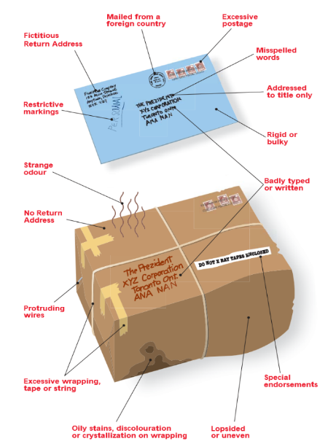

1. Immediately advise your supervisor, Campus Security and RCMP (911)
2. Do not handle, shake, smell or taste the item
3. Isolate the area if required
4. Wash your hands with soap and water
5. Follow the instructions given by emergency personnel

Figure 1: Signs of a suspicious package

# In the event of an Active Shooter

**Building Emergency Director, Floor Warden and Building Occupants – Instructions**

An active shooter situation may not occur at UBC, but it can happen – either here or elsewhere. An active shooter is a person actively shooting at people, usually at random, in a confined or populated area. In most cases, there is no pattern or method to their actions. Active shooter situations evolve quickly and can be over in 10 to 15 minutes. Refer to [www.ubc.ca](http://www.ubc.ca) or all updates in the event of an incident occurring (media reports may be unreliable).

If faced with an active shooter incident, there are THREE things you can do that make a difference. **RUN, HIDE, FIGHT.**

**What to do if there is an active shooter is in your building**

1. **RUN** (get out) if you determine it is safe. This is your first and best option.
2. Leave your belongings behind.
3. Advise others not to enter the danger zone.
4. Call 911 (RCMP) as soon as it is safe to do so. See Note 3.

**Note 3:** The first police officers to arrive will not respond to or aid those who are injured. They will go directly to the shooter. Know that help for the injured is on its way. Lastly, the area is a crime scene. Police may secure all witnesses until identified and questioned.

**Actions to Avoid**:

* Do NOT use or hide in washrooms.
* Do NOT travel down long corridors.
* Do NOT assemble in large open areas (e.g. cafeterias).

**What to do if evacuation from your building is not safe**

1. Find a place to **HIDE.**
2. Lock and/ or barricade the door.
3. Turn off or silence your cell phone, including the vibrate feature.
4. Hide behind large objects if possible.
5. Stay low, below the window level and be quiet.
6. Close curtains or blinds where possible.
7. Await instructions or escort from law enforcement (if unsure they will have a key). If the fire alarm is activated, remain where you are and await further instructions from emergency personnel.

**What to do if your life is in danger**

1. **FIGHT** if you feel your life is in danger (it is the last resort).
2. Attempt to incapacitate the shooter.
3. Act with physical aggression.
4. Improvise weapons.
5. Commit to your actions.
6. Call 911 (RCMP) once the shooter is incapacitated. See Note 3.

**What to do when law enforcement arrives**

1. Keep your EMPTY hands raised and visible.
2. Remain calm and follow instructions.
3. Avoid pointing or yelling.

# Fire Evacuation Drills – Procedures and Records

As per BC Fire Code (See **Appendix 8: BC Fire Code 2012**, Section 2.8.3 Fire Drills), fire drills must be conducted at least once per year. They are intended primarily to ensure that all Building Occupants know how to respond safely and effectively in the event of a life-threatening emergency.

It is the responsibility of the Building Emergency Director when arranging a fire drill to:

1. Contact the Building Operation Service Centre (604 822 2173) to request an “Annual Fire Drill”
2. They submit a service request for a representative from Building Operations Fire Life Safety to sound the alarms in your building.  The following information is required:

* Date and time of drill (Recommended days are Tuesday to Thursday, Times to avoid are: 6:30 – 9:15am, 11:15 – 12:15, and 3:00pm – 3:30pm)
* Location: Building name and address
* Contact information of person making the request

1. A representative from Building Operations Fire Life Safety will contact you to confirm the date and time they will be able to attend.

If you have any questions about your building, contact your [UBC Facility Manager](http://www3.buildingoperations.ubc.ca/facility-manager-search/)

**Record of Fire Drills**

Fire Drills were conducted on the following date(s):

|  |  |  |  |
| --- | --- | --- | --- |
| **DATE/TIME** | **ARRANGED BY** | **TOTAL BUILDING EVACUATION TIME** | **ATTENDED BY FIRE DEPARTMENT? YES/NO** |
|  |  |  |  |
|  |  |  |  |
|  |  |  |  |
|  |  |  |  |
|  |  |  |  |

Please indicate on the Joint Occupational Health and Safety Committee or Local Safety Team (LST) meeting minutes any follow up items noted following a fire drill.

NOTE: You must maintain records of fire drills conducted and forward the results (date and time of drill and total building evacuation time) to the Safety Program Advisor at [RMS- Safety Programs](mailto:safety.programs@riskmanagement.ubc.ca)

# Appendix 1: Automated Emergency Defibrillator Locations

AED Location List- November 2016

Beaty Biodiversity Centre, 2212 Main Mall, West Entrance (114)

|  |  |  |
| --- | --- | --- |
| **AED Location** | | **Building Address** |
| *Acadia Park Residences* | 2707 Tennis Crescent | |
| *Allard Hall (x 4 units)* | 1822 East Mall | |
| *Alumni Centre* | 6163 University Boulevard | |
| *Anthropology & Sociology* | 6303 NW Marine Drive | |
| *Aquatic Centre (NEW)* | 6080 Student Union Boulevard | |
| *Asian Centre* | 1871 West Mall | |
| *Barber Library* | 1961 East Mall | |
| *Baseball Training Facility* | 3085 Wesbrook Mall | |
| *Beaty Biodiversity Centre* | 2212 Main Mall | |
| *Belkin Art Gallery* | 1825 Main Mall | |
| *Biological Sciences* | 6270 University Boulevard | |
| *Bookstore* | 6200 University Boulevard | |
| *Botanical Gardens (x2)* | 6804 SW Marine Drive | |
| *Brock Hall* | 1874 East Mall | |
| *Buchanan Block A* | 1866 Main Mall | |
| *Buchanan Tower (x2)* | 1873 East Mall | |
| *Campus Security* | 2133 East Mall | |
| *Cecil Green Park House* | 6251 Cecil Green Park Road | |
| *Centre for Comparative Medicine* | 4145 Wesbrook Mall | |
| *Chan Centre for the Performing Arts* | 6265 Crescent Road | |
| *Chemical and Biological Engineering* | 2360 East Mall | |
| *Chemistry* | 2036 Main Mall | |
| *Child Care Services Main Office* | 2881 Acadia Road | |
| *Civil and Mechanical Engineering* | 6250 Applied Science Lane | |
| *CK Choi* | 1855 West Mall | |
| *Continuing Studies* | 2121 West Mall | |
| *David Strangway* | 5950 University Boulevard | |
| *Donald Rix (3rd Floor Parking Office)* | 2389 Health Sciences Mall | |
| *Doug Mitchell Thunderbird Sports Centre* | 6066 Thunderbird Blvd | |
| *Earth Systems Science (ESSB)* | 2207 Main Mall | |
| *Environmental Services Facility (ESF)* | 6025 Nurseries Road | |
| *First Nations Longhouse* | 1985 West Mall | |
| *Food, Nutritional & Health* | 2205 East Mall | |
| *Forest Sciences* | 2424 Main Mall | |
| *Frank Forward* | 6350 Stores Road | |
| *Fraser Hall Residence* | 2550 Wesbrook Mall | |
|  |  | |
|  |  | |
| *Friedman* | 2177 Wesbrook Mall | |
| *Gage Residence* | 5959 Student Union Boulevard | |
| *Geography* | 1984 West Mall | |
| *Green College* | 6201 Cecil Green Park Road | |
| *Hennings* | 6224 Agricultural Road | |
| *Henry Angus* | 2053 Main Mall | |
| *Huckleberry Daycare* | #101 2725 Osoyoos Crescent | |
| *ICICS/CS* | 2366 Main Mall | |
| *International House* | 1783 West Mall | |
| *Iona Building (School of Economics)* | 6000 Iona Drive | |
| *JB McDonald* | 2199 Wesbrook Mall | |
| *Jack Bell – Social Work* | 2080 West Mall | |
| *Kaiser* | 2332 Main Mall | |
| *Kenny* | 2136 West Mall | |
| *Klinck* | 6356 Agricultural Road | |
| *Koerner Library* | 1958 Main Mall | |
| *Life Sciences Centre* | 2350 Health Sciences Mall | |
| *Liu Centre* | 6476 NW Marine Drive | |
| *MacMillan* | 2357 Main Mall | |
| *Marine Drive Residence (Building 3)* | 2205 Lower Mall (Building 3) | |
| *Michael Smith Laboratories* | 2185 East Mall | |
| *Museum of Anthropology* | 6393 Northwest Marine Drive | |
| *Music* | 6361 Memorial Road | |
| *NEST (AMS)* | 6133 University Boulevard | |
| *Old Administration* | 6328 Memorial Road | |
| *Old Rugby Pavilion* | 2584 East Mall | |
| *Orchard Commons (x2)* | 6363 Agronomy Road | |
| *Osborne Centre (Building #1) (x 2 units)* | 6108 Thunderbird Blvd. | |
| *Osborne Centre (Building #2) (x 2 units)* | 6108 Thunderbird Blvd | |
| *Owl at the Barn Daycare* | 2323 Main Mall | |
| *Parking Impound Office* | 2451 East Mall | |
| *Pharmaceutical Sciences* | 2405 Wesbrook Mall | |
| *Place Vanier Residence* | 1935 Lower Mall | |
| *Ponderosa Commons Residence* | 2075 West Mall | |
| *Point Grill Restaurant (Building 4)*  *at Marine Drive Residence* | 2205 Lower Mall (Building 4) | |
| *Pulp & Paper* | 2385 East Mall | |
| *Rosegarden Parkade* | 6278 NW Marine Drive | |
| *Scarfe* | 2125 Main Mall | |
| *School of Population Health* | 2206 East Mall | |
| *Sitka Daycare Centre* | 5620(B) Osoyoos Crescent | |
| *St. John's College* | 2111 Lower Mall | |
| *Student Rec Centre* | 6000 Student Union Boulevard | |
| *TEF 3* | 6190 Agronomy Road | |
| *Tennis Centre* | 6160 Thunderbird Boulevard | |
| *Thunderbird Residence* | 6335 Thunderbird Crescent | |
| *Thunderbird Stadium (x 6 units)* | 6288 Stadium Road | |
| *Thunderbird Warehouse* | 2440 West Mall | |
| *Totem Residence* | 2525 West Mall | |
| *UBC Farm* | 3461 Ross Drive | |
| *University Centre* | 6331 Crescent Road | |
| *University Neighbourhood Association (UNA) - Old Barn Community Centre* | 6308 Thunderbird Boulevard | |
| *University Services Building* | 2329 West Mall | |
| *War Memorial Gym* | 6081 University Boulevard | |
| *Wesbrook* | 6174 University Boulevard | |
| *West Coast Suites at UBC* | 5961 Student Union Boulevard | |
| *Woodward IRC* | 2194 Health Sciences Mall | |

**NOTE:** This AED location list was put together in November 2016, so new AEDs can exist in your building or around campus since list was added to the BERP. Please check [RMS Website](http://rms.ubc.ca/health-safety/safety-programs/first-aid/automated-external-defibrillators/#Where%20are%20AEDs%20located%20on%20the%20Vancouver%20campus?) for the most up-to-date locations of AEDs.

# Appendix 2: Emergency Response Key Plans

To obtain Emergency Response Key Plans for your building, go to the Records Retrieval System which can be accessed here: <http://www.infrastructuredevelopment.ubc.ca/rrs2/>

1. Log in with your username and password. If you don’t have one, you can register for website access by filling out the online form.
2. Once you are in the system, click “building records”, and type your building name or number in the search box.
3. On the right hand side, under “link” click on “more”
4. Under the heading “Keyplans” click on “Emergency Keyplans” If this title reads “Emergency Response Key Plans x 0,” that means that your particular buildings plans have not been uploaded yet.
5. Upon downloading your EKP’s, ensure that all the locations of your equipment is correct and that the Predesignated Meeting Area is accurately noted.
6. If modifications to your EKP are required or your EKP’s are not uploaded, contact Pauline Li ([Pauline.li@ubc.ca)](mailto:Pauline.li@ubc.ca)

Emergency Response Key Plans should include the location of the following (if applicable):

***Click on check box to fill in***

Automated External Defibrillators (AEDs)

Emergency exits

Emergency lighting

Emergency power

Fire alarm pull station

Fire extinguisher(s)

Fire hose cabinets

Standpipes

Fire hydrant(s)(outside building)

Fire pump

Sprinkler system

Area(s) of Refuge

Insert a copy of the Emergency Response Key Plan for each floor of your building on or after this page. Emergency Response Key Plans are posted on walls near emergency exits for each floor of every building. It is recommended to have a set of the Emergency Response Key Plans posted on building safety or information boards for building occupants to refer to.

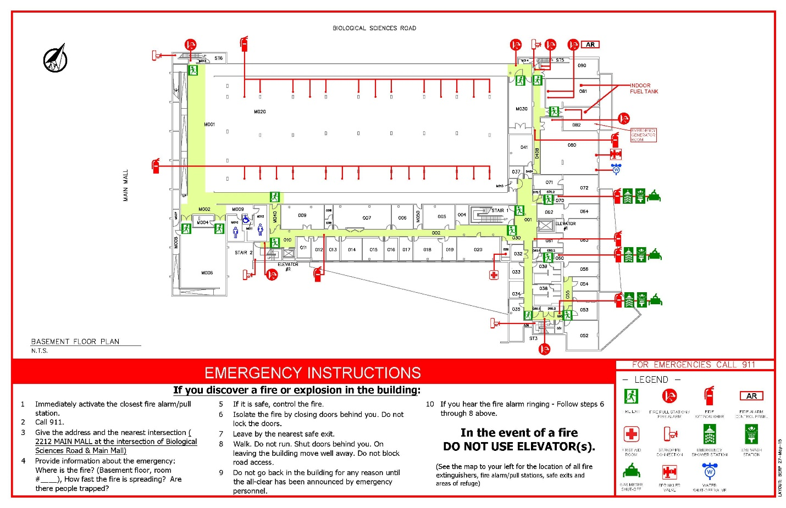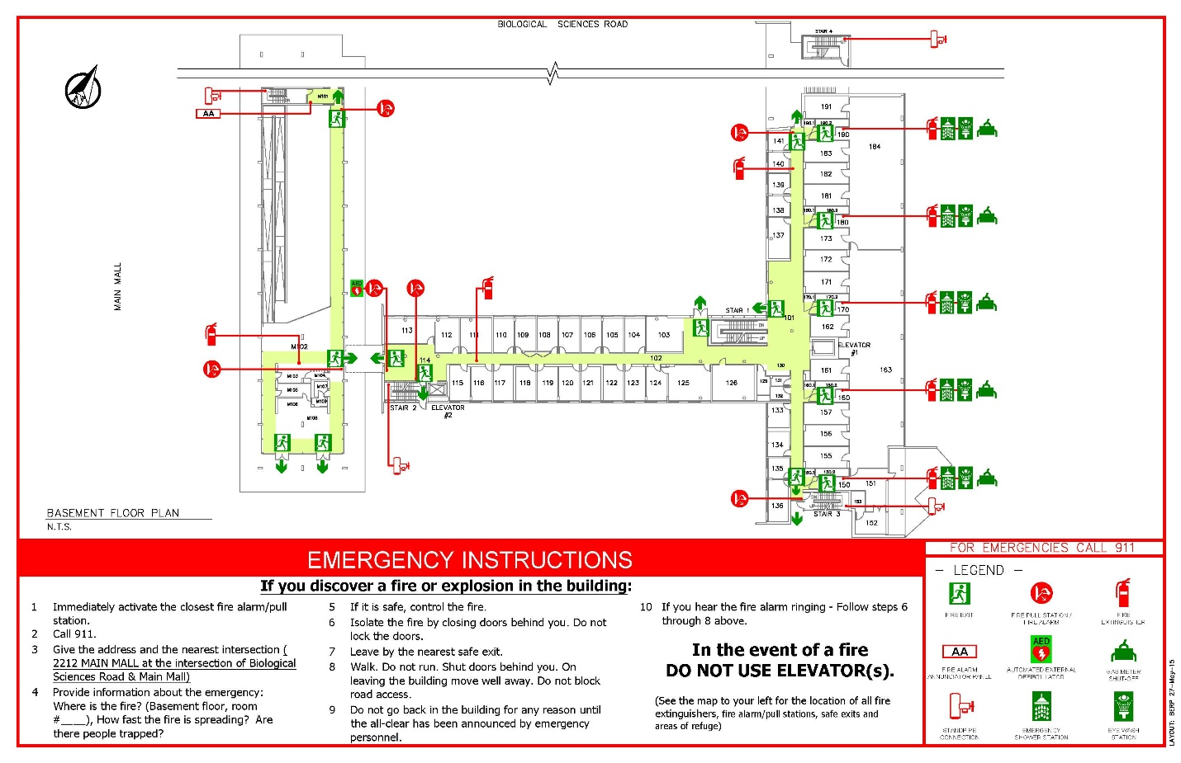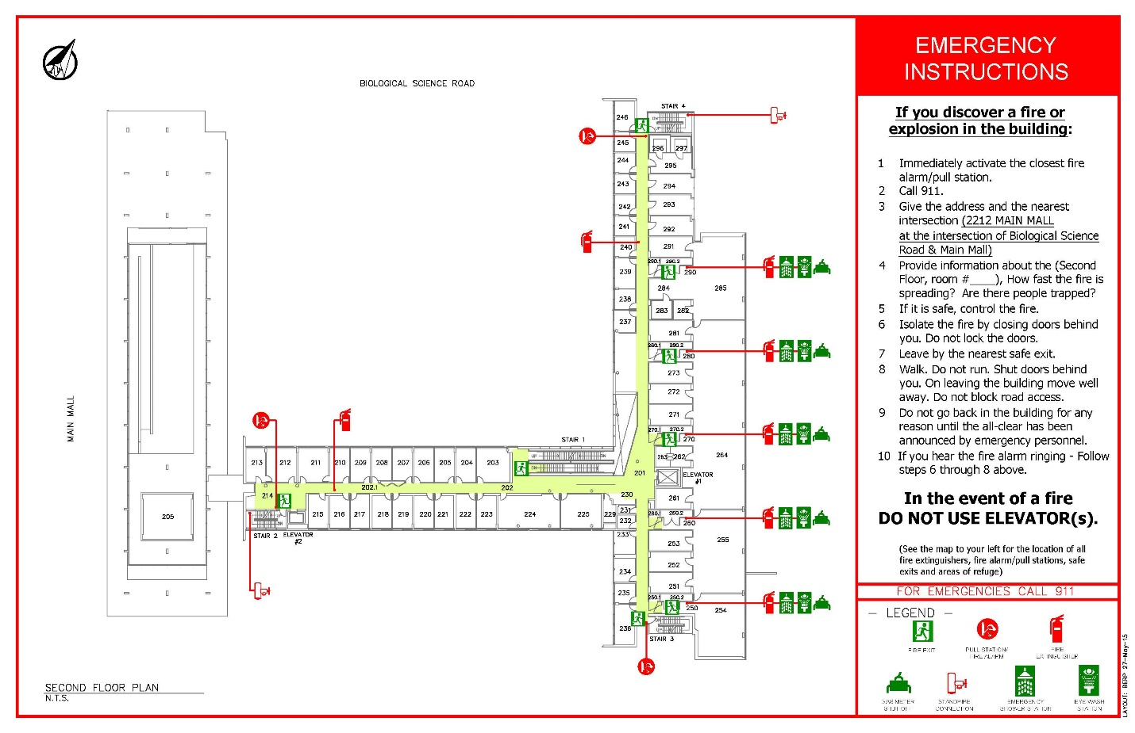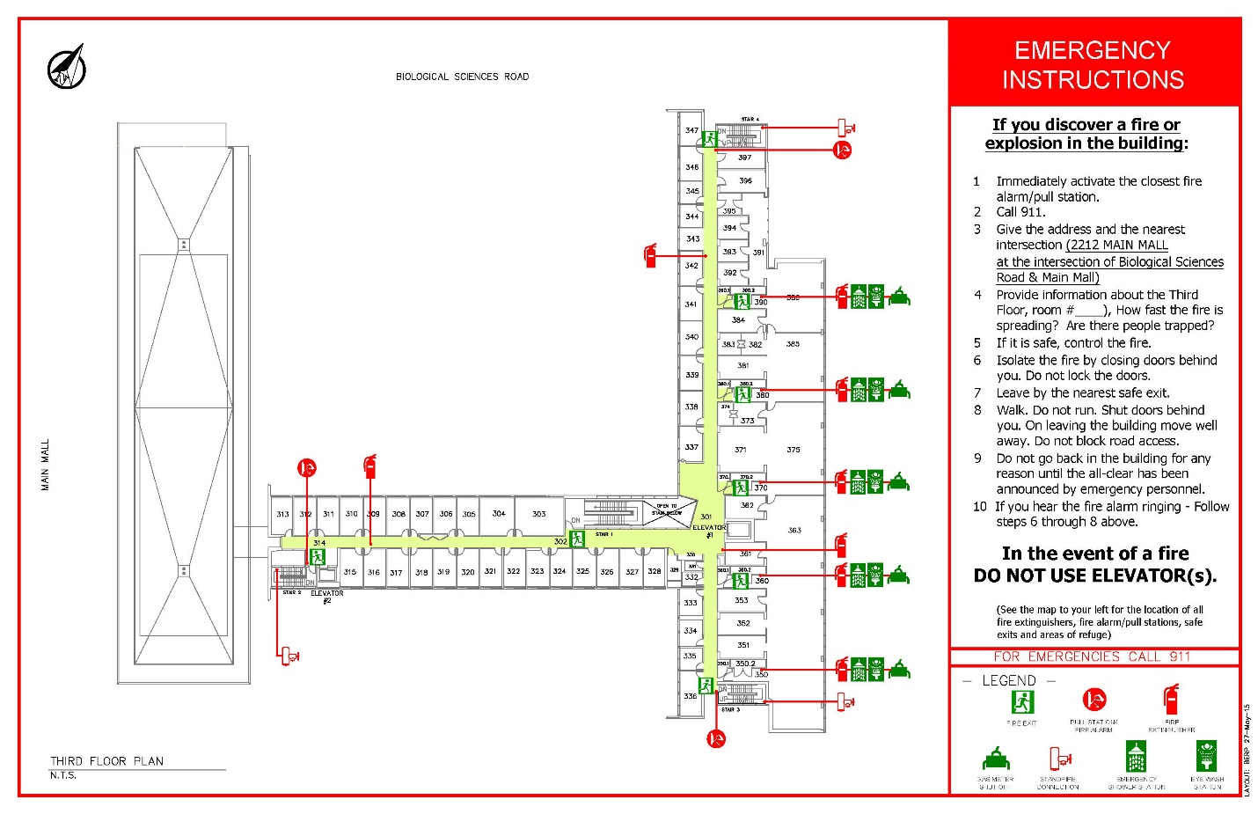

# Appendix 3: Building Site Plan

 This is a map which shows the location of your building, nearest cross streets, location of fire hydrants, etc.

# Appendix 4: Persons Requiring Assistance

**Scope**

Building Occupants who can relate to any of these general disabilities should develop an evacuation plan prior to an emergency evacuation: mobility, visual, hearing, speech, and cognitive (use **Appendix 5: Personal Evacuation Plan** to as a template to document your plan guide).

In any case, when a Building Occupant is left in the building during an emergency evacuation the Building Floor Warden, the Building Emergency Director, and then the Fire Department need to be immediately notified.

**Persons Providing Assistance**

Predetermined persons providing assistance can be anyone in the office or building such as a co-worker, friend, building staff, supervisor, Building Floor Warden, etc. Whether one person or multiple people are required to provide assistance, alternate people should be identified and this information should be recorded in the BERP and/ or other written plans. Providing Assistance is entirely voluntary and can be performed to varying degrees as seen below.

**Type of assistance provided includes:**

* Guidance
  + Explaining information about where to go, the type of emergency occurring, and what needs to be done
  + Escorting the persons to the Area of Refuge or safe location to shelter or to the exit
* Minor Physical Effort
  + Offering an arm to assist the persons
  + Opening the door(s)
* Major Physical Effort
  + Operating a stair-descent device
  + Participating in carrying a wheelchair down the stairs
  + Carrying a person down the stairs

**Training**

Where person(s) with impairment(s) has to make an exceptional effort to get out unaided, it may not be practical for them to practice during drills. However, timing a short section of the escape will assist in establishing how long a full escape might take.

**Where will the person(s) start providing assistance?**

* From the location of the Person Requiring Assistance
  + The person providing assistance and the person requiring assistance should determine the best method for communication (face-to-face, phone, e-mail, etc.) prior to an emergency evacuation.
* From a specific, predetermined location such as the entry to the stairs.

**How will the person(s) providing assistance be contacted?**

* Face-to-face
* Phone
* Email

**When will the person(s) provide assistance?**

* Always
* Only when asked

**Mobility**

Mobility impairments include individuals with wheelchairs, individuals who can walk but with difficulty, individuals who have difficulty using building features such as stairs, individuals with respiratory impairments, etc. Additionally, persons with mobility impairments can hear standard alarms and voice announcements and can see activated visual notification appliances (strobe lights) that warn of danger and the need to evacuate.

People with any type of mobility impairments should be provided with a map showing all emergency evacuation routes including alternate evacuation routes. Written plans should include information on assistance devices (i.e. where they are kept, how to use them, etc.) and/ or the type of method used to carry an individual (e.g. cradle carry or swing carry), if applicable. Training, practice, and an understanding of the benefits and risks of using assistance devices and/ or carrying methods are important and necessary aspects of the planning process.

Important notes:

* Persons with mobility impairments may require assistance with operating door locks, latches, and other devices due to impairments of their hands, fingers, legs, feet, or arms.
* Persons with mild to severe mobility impairment may require assistance to exit the building. A personal evacuation plan should be developed (See **Appendix 5: Personal Evacuation Plan**).

**Visual**

* Persons with visual impairments (i.e. blind or with low vision) can hear standard building fire alarms and voice announcements that warn danger or the need to evacuate or that provide instructions. On the other hand, persons with visual impairment may not be able to evacuate on their own. It is important to verify prior to an emergency evacuation if persons with visual impairments can evacuate unassisted or not (this information should be detailed in a personal evacuation plan). See **Appendix 5: Personal Evacuation Plan Template**.

Important notes:

* Exit signage and directional signage for those with visual impairments is clearly and strictly specified by codes (requirements include type, size, spacing, color of letters, etc.). Tactile signage must be designed and properly located so they can be readily found by a person with a visual impairment from any direction of approach to the exit access.
* If tactile signage is used in the workplace, it may be practical to physically take persons with visual impairments to these areas.
* During an emergency evacuation, pre-determined evacuation routes may be obstructed, persons with visual impairment will need to know if an alternate route should be taken.

The personal evacuation plan for a person with a visual impairment needs to be prepared and kept in the alternative format preferred by that person, including but not limited to Braille, large type, or tactile characters.

**Hearing**

Persons with hearing impairments cannot hear alarms and voice announcements that warn of danger and the need to evacuate. Many codes require new buildings to have flashing strobe lights (visual devices) as part of the standard building alarm system, but because the requirements are not retroactive many buildings do not have them. Additionally, strobe lights are required only for fire alarm systems and simply warn that there may be a fire, and not for other type of emergency evacuations systems.

It is extremely important for people with hearing impairments to know what visual notification systems are in place. They need to be aware of which emergencies will activate the visual notification systems and which emergencies will not. Alternative methods of notification need to be put in place in your workplace for people with hearing impairments so they can get all the information they need to evacuate in a timely manner.

Once notified, people with hearing impairments can read and follow standard exit and directional signs.

Important notes:

* If a person with a hearing impairment is likely to be in one location for a significant period of time, such as at a desk in an office, installation of a reader board in the work area might be useful.
* Other notification methods include personal notification devices which can be activated by a building’s alarm system, instant email, or phone communications.

**Speech**

People with speech impairments can hear standard alarms and voice announcements and can see visual indicators that warn of danger and the need to evacuate. Once notified, people with speech impairments can use any standard means of egress and can read and follow standard exit and directional signs.

Elevators are required to have both a telephone and an emergency signaling device. People with speech impairments should be aware of whether the telephone is limited to voice communications and where the emergency device rings - whether it connects or rings inside the building or to an outside line - and who would be responding to it. Additionally, they may need some assistance with voice communication devices in an elevator.

**Cognitive**

Persons with cognitive impairments can understand hear standard alarms and voice announcements and see visual indicators that warn of danger and the need to evacuate. However, they may not have the ability to recognize and understand emergency alarm systems or other emergency features and what they mean. If person does not recognize and understand alarms systems or emergency features, then plans need to be developed.

Cognitive impairments prevent a person from using or accessing building features due to an in an inability to process or understand the information necessary to use the features. In general, persons with cognitive impairments have some decreased level of ability to process or understand information or situations. It should be verified whether a person with a cognitive impairment has the ability to find and use the exits. If not, plans for assistance need to be developed.

Possible accommodations for emergency evacuation for people with cognitive impairments:

* Providing a picture book of drill procedures and/ or simple floor plans
* Colour coding fire doors and exit ways
* Implementing a buddy system
* Using a job coach for training

**General Tips for persons requiring assistance**

* Ask others for input, such as community directors, staff, faculty, supervisors, and co-workers.
* Choose two evacuation routes for each building
* Assign primary and alternate assistants
* Do not consider using elevators in your plan
* Consider alternative carry and/or communication methods.
* Attach written instructions to all disability related equipment
* Think about your needs for preparedness kits, for example, disability related equipment, communication devices, service animal food, and three days’ worth of medication, if applicable.
* Have a list of all your medications (names, dose, frequency, and name of doctor).
* Have easy access to emergency contact information at all time.
* Participate in drills and review effectiveness of plan.

**References**

Dartmouth College. (September 2005). Special Assistance Needs and Disability Emergency Building Evacuation Plan.

NFPA. (June 2016). Emergency Evacuation Planning Guide for People with Disabilities. National Fire Protection Association.

# Appendix 5: Personal Evacuation Plan

*\*Complete this form only if you need special assistance to evacuate in an emergency.* The person with impairments must be involved in preparing the plan.

**NOTE:** To respect personal privacy, please obtain consent from each of the individuals indicated on the table below prior to posting a public copy of the Building Emergency Response Plan building.

|  |  |
| --- | --- |
| **Personal Evacuation Plan Developed for:** | Name |

|  |  |  |
| --- | --- | --- |
| **PART 1: YOUR PRIMARY LOCATION** | | |
| Building | Room Number | Department |
| **PART 2: YOUR CONTACT INFORMATION** | | |
| Primary Phone | Cell Phone | Email Address |
| **PART 3: ASSISTANCE** | | |
| Detail the number of assistants required and the role of the assistant considering the following factors (use of disability related equipment, use of area of refuge or “safe location to shelter,” assisting until a certain point or until safely out of the building, are service animals involved?) | | |
| **PART 4: CONTACT INFORMATION FOR PRIMARY ASSISTANT(S)** | | |
| Primary Phone | Cell Phone | Email Address |
| **PART 5: CONTACT INFORMATION FOR ALTERNATE* ASSISTANT (S)**  **\*Alternates are to assist when the primary assistants are not available** | | |
| Primary Phone | Cell Phone | Email Address |
| **PART 6: PRIMARY EVACUATION ROUTE** | | |
| Describe the primary route that will be taken and attach a map outlining it | | |
| **PART 7: SECONDARY EVACUATION ROUTE** | | |
| Describe the secondary route that will be taken and attach a map outlining it | | |
| **PART 9: TRAINING FOR THE ASSISTANT** | | |
| Is Training required for the assistant? | Is the required training required training completed by the assistant? | Is there documentation showing completed training? |
| **PART 10: PERSONAL EMERGENCY PREPAREDNESS KIT (if applicable)** | | |
| Detail the location of any Personal Emergency Preparedness Kit | | |

# Appendix 6: Elevator Upgrade Project

The Elevator Code has been revised to ensure that the fire department can use the elevator during a fire. As a result of the is code the university has performed upgrades elevators that enable the Fire Department the ability to manually control elevators in emergency situations. The upgraded elevators will have a smoke detector installed in the lobby of the elevator on every floor. When smoke is detected, the elevators will not operational to building occupants but can still be manually operated by the fire department. For more information on these upgrades please contact Building Operations Fire Life Safety at [fls.buildingops@ubc.ca](mailto:fls.buildingops@ubc.ca)

# Appendix 7: Operating a Fire Extinguisher

# 

The following instructions are applicable for most fire extinguishers. However, it is recommended that Building Fire Wardens take instruction in operating fire extinguishers. This is no longer done by the Fire Department or Risk Management Services and training must be arranged through a private contractor.

Building Floor Wardens should concentrate on a safe evacuation of their area of responsibility if they are not trained in fire extinguisher operation.

If you need to use a fire extinguisher, remember the word PASS –

* **Pull** the pin – Fire extinguishers often have a pin, latch, or puncture lever that you need to release first.
* **Aim** low – Aim the nozzle or hose of the extinguisher at the base of the fire.
* **Squeeze** the handle – This releases the extinguishing agent.
* S**weep** from side to side – Move in close, and sweep across the base of the fire. Always back away and watch for rekindling of the fire.

Discharge the entire contents of the extinguisher. If possible, pull apart the burned area to get at hot spots.

Immediately contact Building Operations Service Centre at 604-822-2173 and arrange for the fire extinguisher to be recharged.

*Foam and water extinguishers require a slightly different technique. Always read the instructions on the label before you need to use a fire extinguisher.

**Appendix 8: BC Fire Code 2012 Excerpt**

**British Columbia Fire Code 2012, Section 2.8 Emergency Planning**

* + 1. **General**
       1. **Application**

1. Fire emergency procedures conforming to this Section shall be provided for
   1. Every *building* containing an *assembly,* <*care,* treatment or *detention occupancy>*
   2. Every *building* required by the British Columbia Building Code to have a fire alarm system,
   3. Demolition and construction sites regulated under Section 5.6.,
   4. Storage areas required to have a fire safety plan in conformance with Articles 3.2.2.5. and 3.3.2.9.,
   5. Areas where *flammable liquids* or *combustible liquids* are stored or handled, in conformance with Article 4.1.5.5., and
   6. Areas where hazardous processes or operations occur, in conformance with Article 5.1.5.1.
      * 1. **Training of Supervisory Staff**
2. *Supervisory staff* shall be trained in the fire emergency procedures described in the fire safety plan before they are given any responsibility for fire safety. (See Appendix A of the BC Fire Code).
   * + 1. **Keys and Special Devices**

**1)** Any keys or special devices needed to operate the fire alarm system or provide access to any fire protection systems or equipment shall be readily available to on-duty *supervisory staff.*

* + 1. **Fire Safety Plan**
       1. **Measures in a Fire Safety Plan**

1. In *buildings* or areas described in Article 2.8.1.1., a fire safety plan conforming to this Section shall be prepared in cooperation with the fire department and other applicable regulatory authorities and shall include
   1. The emergency procedures to be used in case of fire, including
      1. Sounding the fire alarm (see Appendix A of the BC Fire Code),
      2. Notifying the fire department,
      3. Instructing occupants on procedures to be followed when the fire alarm sounds,
      4. Evacuating occupants, including special provisions for persons requiring assistance (see Appendix A of the BC Fire Code),
      5. Confining, controlling and extinguishing the fire,
   2. The appointment and organization of designated *supervisory staff* to carry out fire safety duties,
   3. The training of *supervisory staff* and other occupants in their responsibilities for fire safety,
   4. Documents, including diagrams, showing the type, location and operation of the *building* fire emergency systems,
   5. The holding of fire drills,
   6. The control of fire hazards in the *building,* and
   7. The inspection and maintenance of *building* facilities provided for the safety of occupants.

(See Appendix A of the BC Fire Code).

1. The fire safety plan shall be reviewed at intervals not greater than 12 months to ensure that it takes account of changes in the use and other characteristics of the *building.*
   * + 1. **Care, <Treatment> and Detention Occupancies**
2. A sufficient number of *supervisory staff* shall be on duty in *care, <treatment>* and *detention occupancies* to perform the tasks outlined in a fire safety plan described in Clause 2.8.2.1.(1)(a).
   * + 1. **Assembly Occupancies**
3. In Group A, Division 1 *assembly occupancies* containing more than 60 occupants, there shall be at least one *supervisory staff* member on duty in the *building* to perform the tasks outlined in the fire safety plan in Clause 2.8.2.1.(1)(a) whenever the *building* is open to the public.
   * + 1. **High Buildings**
4. In *buildings* within the scope of Subsection 3.2.6. of Division B of the British Columbia Building Code, the fire safety plan shall, in addition to the requirements of Sentence 2.8.2.1.(1), include
   1. The training of *supervisory staff* in the use of the voice communication system,
   2. The procedures for the use of elevators,
   3. The action to be taken by *supervisory staff* in initiating any smoke control or other fire emergency systems installed in a *building* in the event of fire until the fire department arrives,
   4. Instructions to the *supervisory staff* and fire department for the operation of the systems referred to in Clause (c), and
   5. The procedures established to facilitate fire department access to the *building* and fire location within the *building*.
      * 1. **Retention of Fire Safety Plans**
5. The fire safety plan shall be kept in the *building* for reference by the fire department, *supervisory staff* and other personnel.
6. The fire safety plan for a *building* within the scope of Subsection 3.2.6. of Division B of the British Columbia Building Code shall be kept at the central alarm and control facility.
   * + 1. **Distribution**
7. A copy of the fire emergency procedures and other duties for *supervisory staff*, as laid down in the fire safety plan, shall be given to all *supervisory staff.*
   * + 1. **Posting of Fire Emergency Procedures**
8. At least one copy of the fire emergency procedures shall be prominently posted on each *floor area*.
9. In every hotel and motel bedroom the fire safety rules for occupants shall be posted showing the locations of *exits* and the paths of travel to *exits*.
10. Where a fire alarm system has been installed with no provisions to transmit a signal to the fire department, a sign shall be posted at each manually actuated signaling box requesting that the fire department be notified, and including the telephone number of that department.
11. <All *buildings* served by one or more elevators shall have, at each elevator entrance on each floor level, a permanently mounted fire safety sign or symbol indicating that the elevator is not to be used in case of fire.
12. The sign or symbol required by Sentence 2.8.2.7. (4) shall be at least 100 mm in height and width and shall be designed in accordance with NFPA 170 “Standard for Fire Safety and Emergency Symbols”.>
    * 1. **Fire Drills**
         1. **Fire Drill Procedures**
13. The procedure for conducting fire drills shall be determined by the person responsible in charge of the *building*, taking into consideration
    1. The *building occupancy* and its fire hazards,
    2. The safety features provided in the *building*,
    3. The desirable degree of participation of occupants other than *supervisory staff*,
    4. The number and degree of experience of participating *supervisory staff,*
    5. The features of fire emergency systems installed in *buildings* within the scope of Subsection 3.2.6. of Division B of the British Columbia Building Code, and
    6. The requirements of the fire department.

(See Appendix A of the BC Fire Code.)

* + - 1. **Fire Drill Frequency**

1. Fire drills as described in Sentence 2.8.3.1.(1) shall be held at intervals not greater than 12 months for the *supervisory staff*, except that
   1. In day-care centers and in Group B *major* *occupancies,* such drills shall be held at intervals not greater than one month,
   2. In schools attended by children, total evacuation fire drills shall be held at least 3 times in each of the fall and spring school terms, and
   3. In *buildings* within the scope of Subsection 3.2.6. of Division B of the British Columbia Building Code, such drills shall be held at intervals not greater than 2 months.

# Appendix 9: List of Contributors

The table shown below lists the UBC departments and external agencies that have contributed information as subject matter experts in the development of this document.

|  |  |
| --- | --- |
| **DEPARTMENT/AGENCY** | **NAME (TITLE)** |
| Fire Department | **Rick Cheung**  (Assistant Chief- Fire Protection Engineer UEL/UBC) |
| UBC Building Operations | **Naval Aery**  (Fire & Life Safety Head) |
| UBC Campus Security | **Rob McCloy**  (Executive Director of Campus Safety and Security) |
| UBC Energy and Water Services | **Richard Hugli**  (Electrical Utilities Manager) |
| UBC Risk Management Services | **Ron Holton**  (Chief Risk Officer) |
| **Bruce Anderson**  (Director, Occupational & Research Health & Safety) |
| **Danny Smutylo**  (Director, Emergency Management) |
| **Paul Nakagawa**  (Safety Programs Advisor) |
| **Teela Narsih**  (Occupational and Research Safety Associate) |